Satellite Products and Services Review Board

S-NPP Microwave Sounder-based TC Products

External Users Manual
Template

Compiled by Mark DeMaria, Limin Zhao, and Liqun Ma

Version 1.1
June, 2013
___________________________________

Title: S-NPP MICROWAVE SOUNDER-BASED TC PRODUCTS EXTERNAL USERS manual VERSION 1.1

AUTHORS:
Mark DeMaria (NESDIS/StAR)
Andrea Schumacher, Jack Dostalek, and Scott Longmore (CIRA, Fort Collins CO)
Limin Zhao and Liqun Ma (OSPO)
Hazari Syed (OSPO/SSAI)

DOCUMENT HISTORY
DOCUMENT REVISION LOG

The Document Revision Log identifies the series of revisions to this document since the baseline release. Please refer to the above page for version number information.

DOCUMENT TITLE: S-NPP Microwave Sounder-based TC Products External Users Manual
DOCUMENT CHANGE HISTORY
Revision No. | Date | Revision Originator Project Group | CCR Approval # and Date

LIST OF CHANGES

Significant alterations made to this document are annotated in the List of Changes table.

DOCUMENT TITLE: S-NPP Microwave Sounder-based TC Products External Users Manual
LIST OF CHANGE-AFFECTED PAGES/SECTIONS/APPENDICES
Version Number | Date | Changed By | Page | Section | Description of Change(s)

TABLE OF CONTENTS

Page
LIST OF TABLES AND FIGURES 6
1. PRODUCTS 7
1.1. Product Overview 7
1.1.1. Product Requirements 7
1.1.2. Product Team 7
1.1.3. Product Description 7
1.2. Product History 7
1.3. Product Access 8
2. ALGORITHM 9
2.1. Algorithm Overview 9
2.2. Input Satellite Data 9
2.2.1. Satellite Instrument Overview 9
2.2.2. Satellite Data Preprocessing Overview 9
2.3. Input Ancillary Data 9
3. PERFORMANCE 11
3.1. Product Testing 11
3.1.1. Test Data Description 11
3.1.2. Unit Test Plans 11
3.2. Product Accuracy 11
3.2.1. Test Results 11
3.2.2. Product Accuracy 11
3.3. Product Quality Output 11
3.4. External Product Tools 12
4. PRODUCT STATUS 13
4.1. Operations Documentation 13
4.2. Maintenance History 13

LIST OF TABLES AND FIGURES
Page

Table X – Table Title Error! Bookmark not defined.
Figure X – Figure Caption 6

PRODUCTS

Product Overview

Product Requirements
The S-NPP Microwave Sounder-based TC Products required from this algorithm are;

Intensity estimates for every active tropical cyclone for which all input data is available. Intensity estimates will be provided in terms of 1) the maximum sustained surface wind (Vmax) in knots and 2) the minimum sea level pressure (MSLP) in hPa.

Surface wind radii estimates for every active tropical cyclone for which all input data is available. Surface wind radii estimates will be provided for the radius of 34-kt, 50-kt, and 64-kt winds for the NE, NW, SE, and SW tropical cyclone quadrants in units of nautical miles.

Two-dimensional (2-D) balanced winds at standard pressure levels for the local TC environment for every active tropical cyclone for which all input data is available. 2-D balanced wind fields for a 6 x 6 degree domain centered on each active TC will be provided in units of knots at p = 1000, 850, 700, 500, 400, 300, 250, 200, 150, and 100 hPa.

Intensity and surface wind radii estimates are required in text format consistent with the Automated Tropical Cyclone Forecast (ATCF) system. The format required for the ATCF f-decks is described at http://www.nrlmry.navy.mil/atcf_web/docs/database/new/newfdeck.txt. Using this format, a single line of text is generated for each active TC at each run time. An example of this format (for a similar AMSU sounder-based product) is included below:

IO, 91, 201305052327, 30, AMSU, IP, , 580N, 7654E, , 1, 33, 2, 1004, 2, MEAS, , , , , , , , , , , 2, 0, , A, CIRA, JAK, , , , , , , 1004, , NOAA15, , , , , , , , , , , , , , , , , , , 2, storm center extrapolated from t=-12 and t=0 adeck

2-D balanced winds are required in both netCDF and image format. One netCDF file and image will be generated for each active tropical cyclone at each standard pressure level.

Product latency should be the same as the current AMSU sounder-based products, which are available approximately 3 hours after synoptic time or sooner, depending on the time of the last S-NPP pass of the TC.

Product Team
IPT Lead: Mark DeMaria (STAR)
IPT Backup Lead: Limin Zhao (OSPO)
PAL: Liqun Ma (OSPO)
QA Lead – Zhaohui Cheng (OSPO)
Development Team: Andrea Schumacher, Jack Dostalek, Scott Longmore, Galina Chirokova, Robert DeMaria (all CIRA)
Operational Implementation Team: Truc Nguyen(20/20)

Product Description

The S-NPP Microwave Sounder-based TC Products algorithm provides estimates of tropical cyclone intensity and surface wind radii for 34-, 50-, and 64-kt wind thresholds. Intensity and structure estimates are calculated from a combination of ATMS-based temperature and moisture soundings, the hydrostatic relationship, and statistics.

Product History
AMSU-based intensity and wind radii algorithms have been running operationally at NCEP since 2003. Algorithm and validation details are provided in Demuth et al. (2004; 2006). In addition, AMSU-based balanced wind algorithms been running operationally since 2005 (Bessho et al. 2006).

This product is an adaptation of the AMSU-based algorithm that will use MIRS ATMS temperature and moisture soundings. This will ensure that TC forecasters will have continued intensity and structure guidance from the next generation of polar orbiting satellites like the S-NPP ATMS.

Product Access
All NPTC output data files will be made available by the NDE DHS on the NDE data distribution server at ESPC in a near real time manner. For access to this server, information about data files, and associated documentation, the NPTC PAL should be contacted (see Product Team section)

The NESDIS' Policy on Access and Distribution of Environmental Data and Products is provided at: http://www.ospo.noaa.gov/Organization/About/access.html.
Users need to fill out the Data Access Request Form located on this site and submit to the PAL with a copy to nesdis.data.access@noaa.gov. This address provides the OSPO Data Access Team a copy of the correspondence. The process is defined in the following diagram. Once the request is approved by the OSPO management the data will be delivered by the Data Distribution System (DDSProd) currently distributing the ESPC data products and later by the Product Distribution and Access (PDA) system. The ESPC Data Distribution Manager, Donna McNamara (donna.mcnamara@noaa.gov) should be contacted for any data accessibility and data distribution problems.
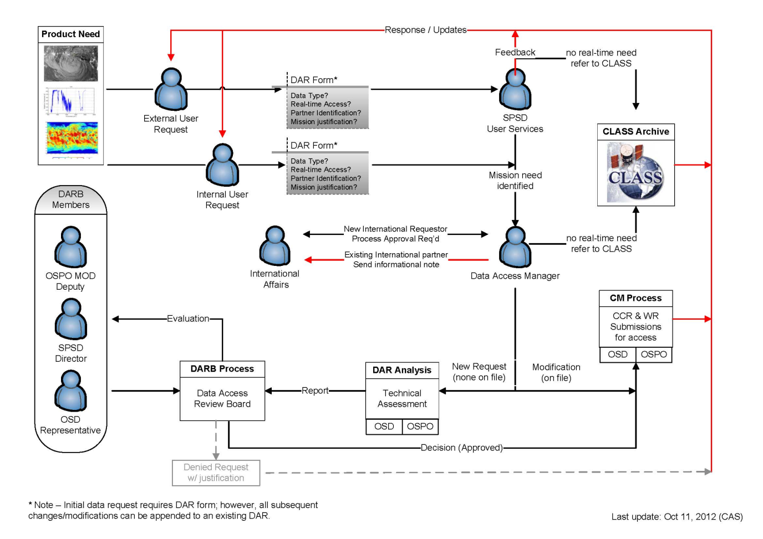

In order to obtain the near real time data user needs to fill out the Data Access Request Form located on http://www.ospo.noaa.gov/Organization/About/access.html and submits to the PAL with a copy to nesdis.data.access@noaa.gov. CLASS will be archiving the NPTC data products for distributing to the non real time users. NDE pushes the data to CLASS with the associated metadata in the standard formats.

The algorithm produces 6 output ASCII files. The first file is denoted by the extension XYA and contains the meteorological data derived from the satellite measurements in a latitude-longitude-pressure projection. The first line contains the position information of the analyzed tropical cyclone, the second line contains information not only on the position of the cyclone, but also the location of the swath of satellite measurements. The gridded data (currently 0.2°x0.2° latitude/longitude) follow. The columns are latitude (°), longitude (°), u-component of the wind (m s⁻¹), v-component of the wind (m s⁻¹), temperature (K), and height (m). These columns are arranged in sections according to pressure level. The pressure level is given in pascals in a one-line section header. The levels are 10000.0 Pa, 15000.0 Pa, 20000.0 Pa, 25000.0 Pa, 30000.0 Pa, 40000.0 Pa, 50000.0 Pa, 70000.0 Pa, 85000.0 Pa, 92500.0 Pa, and 100000.0 Pa. The last section contains the data for the surface and has 7 columns: latitude (°), longitude (°), u-component of the wind (m s⁻¹), v-component of the wind (m s⁻¹), temperature (K), pressure (Pa), and cloud liquid water (mm). Typical ranges of values are:
- Latitude: 30° S to 30° N
- Longitude: 180° E to 180° W
- U: -50 to 50 m s⁻¹
- V: -50 to 50 m s⁻¹
- T: 190 to 310 K
- Z: -100 to 16000 m
- P: 92000 to 102000 Pa
- CLW: 0 to 0.7 mm
The file size depends on the size of the grid used in the analysis. Currently there are 61x61 horizontal grid points and 12 vertical levels. This configuration results in a file size of 3.1 MB.

The second file has the extension RZA and contains meteorological data in a radial-height projection. The first two lines are identical to the first two lines in the XYA file, giving position information on the tropical cyclone and the satellite swath. The 3rd line gives information on the radial height grid, currently 31 radial point x 21 height points. Four data blocks follow – pressure (mb), density (kg m⁻³), temperature (K), and gradient wind (m s⁻¹). Typical ranges of values are:
- Pressure: 50 to 1020 mb
- Density: 1.2 to 0.1 kg m⁻³
- Temperature: 190 to 310 K
- Gradient wind: -20 m s⁻¹ to 50 m s⁻¹
Typical size for the RZA files is 18.6 KB.

The third file contains the locations of the satellite retrievals that were used in the analysis and has the extension LOC. The first line contains the time of the swath and the name of the associated cyclone. The remaining lines of the file contain longitude/latitude pairs corresponding to the retrieval locations. The files typically have 15000-20000 retrievals and are 250 to 300 KB.

The fourth file has the extension FIX and contains several pieces of information on the cyclone. After listing the date and time of the cyclone and the satellite swath, the intensity of the system is given, in terms of both minimum sea-level pressure and maximum surface winds. The structure of the wind field is recorded in terms of the 34-, 50-, and 64-kt wind radii at 4 different azimuths (NE, SE, SW, NW), and in terms of the radius of maximum winds. The distance of the system center from the center of the satellite swath, and the difference in time between the ATCF input and the satellite data is then given. Finally, information from the ATCF file input is written. These data include the cyclone position, intensity, and direction and speed of movement. Typical ranges of values:
- Minimum sea-level pressure: 920 to 1020 mb
- Maximum surface winds: 20 to 160 kt
- 34 kt wind radii: 75 to 250 nm
- 50 kt wind radii: 50 to 150 nm
- 64 kt wind radii: 15 to 75 nm
- Radius of maximum winds: 10 to 100 nm
- Difference between ATCF time and swath time: 0-8 hrs
The FIX files are around 1.5 KB.

The fifth file has the extension AFX. This file contains the position and intensity of the ATMS analysis, and is in a format suited for its intended purpose, which is to be sent to the ATCF f-deck. An example ATCF format is given in Section 1.1.1 of this document. The format is described in detail at http://www.nrlmry.navy.mil/atcf_web/docs/database/new/newfdeck.txt. Typical values for the entries are the same as for the FIX file. The AFX files are typically 0.4 KB.

The sixth file has the extension STA and contains analysis statistics for the tropical cyclone. The first two lines hold location information about the system and its associated swath. The remaining lines are split into two groups, the first group contains:
- Minimum pressure
- Surface pressure drop
- 3 km pressure drop
- Maximum temperature anomaly
- Height of maximum temperature anomaly
- Swath spacing
- Maximum surface winds
- Radius of maximum surface winds
- Maximum winds at 3 km height
- Radius of maximum winds at 3 km height
- 0 to 250 km mean tangential winds at surface
- 0 to 250 km mean tangential winds at 3 km height
- 0 to 250 km mean tangential winds at 5 km height
- 250 to 500 km mean tangential winds at surface
- 250 to 500 km mean tangential winds at 3 km height
- 250 to 500 km mean tangential winds at 5 km height
- Average cloud liquid water
- Cloud liquid water percent (area greater than 0.5 mm from 0 to 300 km)
- Minimum pressure on the xy-grid
- Latitude of minimum pressure on the xy-grid
- Longitude of minimum pressure on the xy-grid
- Adjusted latitude (center of minimum pressure)
- Adjusted longitude (center of minimum pressure)
With the exception of the longitudes, these values should all be greater than zero. The values relating to wind speeds will typically be tens of m s⁻¹, and the radii measurements in the hundreds of km, pressures 920 to 1020 mb. The maximum temperature anomaly is typically at a height around 10 km. The surface and 3 km pressure drops are typically in the tens of mb. The average cloud liquid water is in the tenths of mm and the cloud liquid water percent will be between 0 and 100.
The second group is entitled “Statistical Intensity/Radii Estimates” and contains:
- AMSU maximum wind and minimum pressure
- Mean 34, 50, 64 kt wind radius
- Fit 34, 50, 64 kt wind radius
- ATCF max wind, speed, heading
- rm and x, which are parameters for the modified Rankine vortex
- 34 kt radii in the NE, SE, SW, and NW quadrants
- 50 kt radii in the NE, SE, SW, and NW quadrants
- 64 kt radii in the NE, SE, SW, and NW quadrants
These values should all be greater than zero. The wind speeds should be 20 to 160 kt, the radii in the tens to hundreds of km range, and the pressure between 920 and 1020 mb. The value rm is typically tens of km, and the value x is usually between 0.4 and 0.6. The STA files are typically 1.1 KB.

All data in the above six files are included in two netCDF4 files. The final output files are:

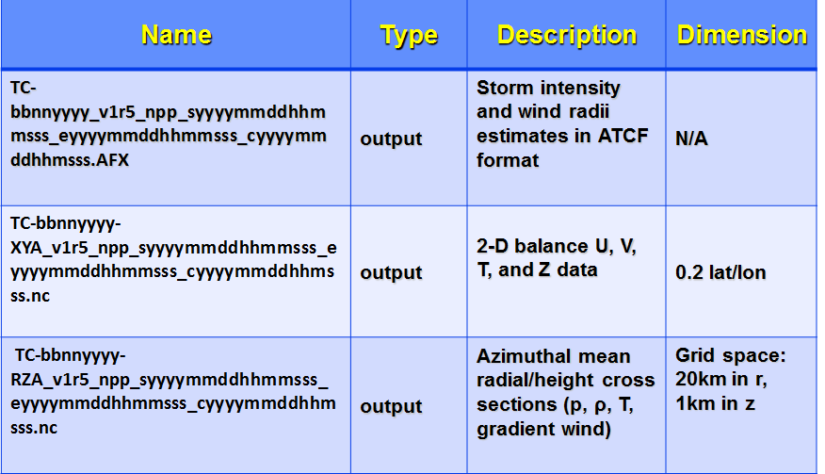

ATCF files will be archived at NHC.

NTCP products in NetCDF4 format will be archived at NCDC.

ALGORITHM

Algorithm Overview
The creation of the wind field from the temperature field derived from satellite measurements is a two-step process. It is first necessary to create a height field from the temperature field. From the height field a wind field is derived. The height field is calculated by integrating the hydrostatic equation using the temperature profiles from the satellite retrievals, with boundary conditions coming from an NCEP/GFS analysis. After computing the height field, the wind field can be obtained by assuming a balance condition linking the height field to the streamfunction. In this algorithm, either linear balance, nonlinear balance or gradient wind balance is used. More details on the method of computing the wind field can be found in Section 2.3.2 of the S-NPP Microwave Sounder-based TC Products ATBD.

Input Satellite Data

Satellite Instrument Overview
Temperature and moisture soundings are obtained from the Advanced Technology Microwave Sounder (ATMS) on S-NPP. The ATMS is a cross-track scanner with a swath width of 2300 km and a spot size of approximately 1.5 km. The S-NPP ATMS has 22 channels that provide sounding observations needed to retrieve profiles of atmospheric temperature and moisture for weather and climate monitoring purposes. These 22 channels are divided into two groups: a low-frequency (23 to 57 GHz) group, and a high-frequency (88 to 183 GHz) group. The low frequency channels, 1 through 15, are primarily for temperature soundings and the high-frequency channels, 16 through 22, are primarily for humidity soundings (water vapor profiling). ATMS combines all channels of the preceding AMSU-A1, AMSU-A2, and AMSU-B sensors and has improved spatial coverage (i.e., no gaps between swaths) over AMSU.

Satellite Data Preprocessing Overview
Satellite data preprocessing is done by MIRS. Please refer to the MIRS ATBD and SMM for details.

2.2.3. Input Satellite Data Description

The input satellite data are the atmospheric profiles derived from the ATMS measurements processed with the MIRS algorithm. The data include temperature and moisture profiles at 100 pressure levels, the total precipitable water, and the cloud liquid water. The latitude, longitude and time of the retrievals are also used. These data are read in from text files which were created from netCDF files of the retrievals.

Input Ancillary Data
The satellite data used by the algorithm is complemented by two forms of ancillary data, the “a-decks” of the Automated Tropical Cyclone Forecast (ATCF), and the Global Forecast System analyses. The ATCF a-deck files contain an estimate of the position of the system at the current time, as well as the position 12 hours prior to the current time. They are ASCII files which have the naming convention abbidyyyy.dat. The letter “a” implies a-deck file, bb is the basin (al-Atlantic, ep-East Pacific, cp-Central Pacific, wp-West Pacific, io-Indian Ocean, sh-Southern Hemisphere), id is the system number, and yyyy is the year. The GFS analysis data include temperature, geopotential height, and the u and v wind components at 100, 150, 200, 250, 300, 400, 500, 600, 700, 850, 925, 1000 mb. The file name is AVN.DAT – the GFS model was previously known as the AVN. The contents are in an encoded ASCII format.

PERFORMANCE

Product Testing

Test Data Description
Test has been done within NDE

Unit Test Plans
Test has been done within NDE

Product Accuracy

Test Results
Test has been done within NDE

Product Accuracy

For preliminary product testing, pre-operational ATMS MIRS datasets were obtained from NESDIS/StAR. 171 cases were analyzed over several months of 2012, and cases included tropical cyclones in four basins (Atlantic, E. Pacific, W. Pacific, and Indian Ocean).

After the application of a simple bias correction, mean absolute error of the sample intensity estimates is 10.2 kts, which is better than the 13.5 kt MAE for the AMSU-based product.

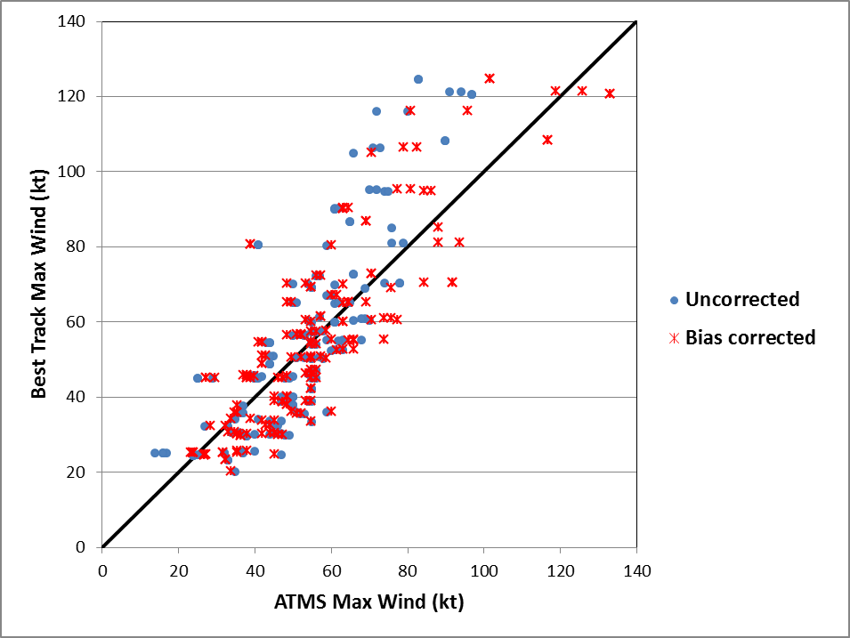
Figure 2-2. MAE of intensity estimates for 171 validation cases run using 2012 pre-operational ATMS MIRS data. Both uncorrected and bias-corrected intensity estimates are shown.

Product Quality Output
Quality flags are included in product output.

External Product Tools
No external product tools are required for viewing product output.

PRODUCT STATUS

Operations Documentation
Operational logs contain the information regarding the changes made to science, instruments, and systems. Basically the Configuration Management system will have the detailed information about these changes, but operational logs keep the high level description of these changes.

Maintenance History

The System Maintenance Manual (SMM) will be updated to reflect the changes that will be required to maintain the NCTP system within the ESPC environment. Information regarding the changes to the products is tracked by the Operational logs and will be available to users on request. Product metadata will be updated as per the changes required in the product including the version number, quality flags etc…

END OF DOCUMENT

